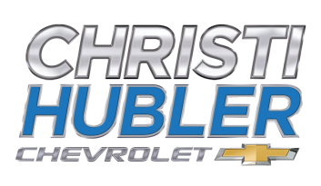

Christi Hubler Chevrolet is proud to present our Educators Program for both Sales and Service
Our Sales Program offers Educators GM Supplier pricing on all new Chevrolets
Each new Chevrolet at Christi Hubler Chevrolet comes with 3 years complimentary service as well as a lifetime powertrain warranty
Our Service Department is offering educators 10% off Service, Parts, and Accessories
Christi Hubler Chevrolet will Pick Up your vehicle, have the oil changed or any other needed service and return the vehicle to you at no cost.
This service program runs 8:30 – 4:00 Monday thru Friday. Simply call the dealership at 765.307.2900 and ask for Brock Whitt or Jeff Myers. You can also email us at bwhitt@hubler.com or jmyers@hubler.com
Thank you for all you do for our community! We look forward to working with you!

Sincerely,
Christi Hubler-Lyskava

